**CL117LAB 01** I**INTRODUCTION Lab Task TO ICT**



**NATIONAL UNIVERSITY OF COMPUTER AND EMERGING SCIENCES**

1 | P a g e

**LAB ACTIVITY**

**Question 01:**

Create a new document Write the following paragraph along with its equation. You will find the equation and symbols in INSERT tab.

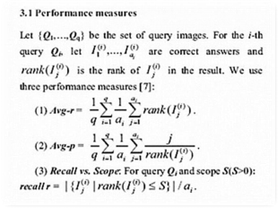

**Question 02:**

Create a file named lab1.docs containing the following text. With the specified changes.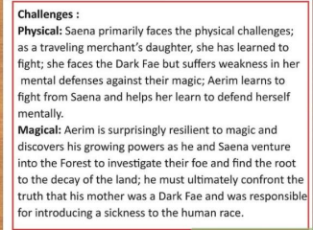

2 | P a g e

a) Font color for every noun should be blue and for verb it should be green. b) Text in bold should be made italic also.

c) First paragraph should be in times new roman (10) and second should be in Arial (10).

d) Nouns Saena and aerim should be in “Blackadder ITC” font size 36.

Note: There should be no green blue or red lines under the text.

**Question 03:**

Write an Article using sample template

a) Insert a 5 lines drop cap at a distance of 0.3cm from text

b) Insert header with your name and page no

c) Set margins Mirrored

d) Landscape orientated, size Tabloid, justified.

e) Insert citation, Bibliography and footnotes where necessary

f) Insert related picture or table with caption

g) Proof read your document and add comments

**Question 04:**

Create a sales Table.

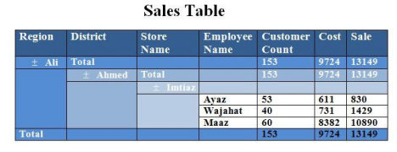**Question 05:**

Create a document and give 5 Footnotes.

▪ Type the 3 Paragraphs of text and apply align left, align right, align justify. ▪ Assign bold, italic, underline for 3 Paragraphs, text background color different and give 3 different fonts for those.

▪ Write 4 different bookmark and use go to book mark options.

▪ Apply auto formatting on text the word is Pakistan.

3 | P a g e

**Question 06:**

Create the document on any topic of your choice, add the picture and wrap the text.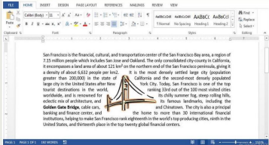

4 | P a g e